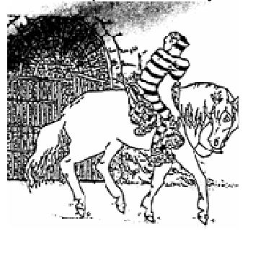

**OLD SELAM**

**“PIONEER”**

**Endurance Ride**

**September 2nd ,3rd & 4th 2022**

**Directions:** From I-84 in Boise take Hwy 21 NE 36 miles to Idaho City. Turn Left (north) onto Montgomery St.

At the end of the street, turn left (west) and continue for 7 miles (dirt road between towns) to Centerville. Turn right (north) onto Henry’s creek Rd. and continue approx. ½ mile into camp.

**Camp:** Camp is on private ground. **Weed Free Hay is required due to use of Forest Service lands.** Horse water will be supplied, but bring people water. **DOGS are always welcome**, but must be leashed at all times. Do NOT bring dogs to registration, vet area, ride meetings or awards dinner. **FIRE** danger is very real this time of year – only one community fire will be allowed, if any. Bring your own food. No meals provided.

**FEE Schedule:**  For Competitive Distances (25-55 miles) $110 for the 1st day ridden, $105 for additional days, current year/reciprocating ride managers 50%off (one day only; other days at full price).  Non-AERC members will be subject to an additional $15 per day non-member fee.  Trail Riders $25 for the 1st day ridden, $20 for additional days: no non-member surcharge for trail riders.

**JUNIORS (under age 18 as of 1/1/22) ride FREE**

**Starting Times:** 50 and 55 mile riders @6:00am; LDs @ 7:00am. Trail ride any time after 9am but no later than 3pm (trail riders must check in & out with ride management). Check-in and vetting to start approx. 4 pm on Thursday Sept 1st for Friday riders, Pre-vet times for Saturday and Sunday will be at the discretion of the Vets.

**Trails:** Trails are primarily old logging roads, ATV and single-track trials on private property, US Forest Service and Idaho State Lands. The terrain is mostly sound footing with sandy surfaces, but there are rocky sections. **Hoof Protection is STRONGLY recommended** for all horses competing.

We will offer 3 fabulous days of riding in the beautiful Boise Basin where

Gold was discovered in 1862, and wonderful treasures are still found today.

Day 1 – Friday September 2nd, 25 and 50 mile endurance rides

Day 2 – Saturday September 3rd, 25 and 55 mile endurance rides

Day 3 – Sunday September 4th, 25 and 50 mile endurance rides

# For more information check out our web page at <http://www.endurance.net/switdr/>

# Our Facebook page at https://www.facebook.com/groups/switdr

# Or our Event page at <https://www.facebook.com/groups/oldselam>

**Ride Manager:** - Southwest Idaho Trail and Distance Riders