Endurance 101 & More Clinic 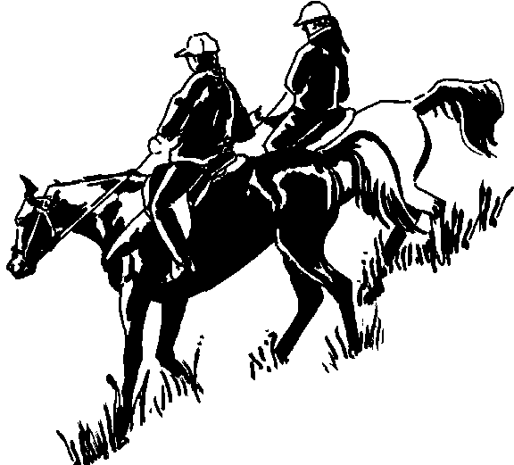
When? Saturday, March 28, 2015 from 1 p.m - 6 ? p.m.
Where? Off Hwy 201 south of Adrian, OR directions supplied with registration request
What? An unmounted/mounted clinic to introduce you to the sport of AERC Endurance Riding -- we will review how the competitions work, how to prepare the horse and rider and how to have not just success, but fun! There will a mock vet check, metabolic checks of horses, how to handle trail emergencies, hands on look at equipment, a little bit about feeding and electrolyting, horse camping, as well as plenty of time for questions and answers. Then we’ll saddle up and go for a ride, cross water, etc. All horses must be group safe. The clinic is geared toward riders new to the sport, either contemplating trying it, or in their first season or two but will be happy to add advanced info .
Who? The clinic will be hosted by Karen Bumgarner and whoever else we can convince to come talk. For additional information, contact Karen Bumgarner zap6000@gmail.com 208-440-8413.
Why? Because this sport is incredibly fun and challenging and ADDICTIVE!
Cost? $85 for butts in the saddle; $40 for non-riders. Clinic registration postmark deadline is March 20th, 2015. Please contact us about space availability after that date. Clinic registration must be paid in full and is non-refundable unless the clinic is cancelled. If clinic fails to fill I will cancel and return checks.
What to Wear? Comfortable clothes, appropriate for in the weather (so bring some layers and appropriate footwear for hands-on work with the horses). We’ll do some introductory time with a lecture/ discussion/presentations and then spend some time with the horses.
What to Expect? You will want to bring a chair, a stethoscope (if you have one—we will have stethoscopes available for use so no need to purchase one) and a watch as well as a notepad/pen to take some notes.
No food will be served. Bring your own snacks and drinks.
The plan is to keep it “green” and not kill too many trees with paper handouts, but will give you a CD full of information, including internet links, ride flyers, and a ton of reading material that will keep you busy for weeks.
Sponsored By? Would love to have sponsors!

Registration Form: Endurance 101 Clinic Must be received by March 20, 2015
NAME: ___________________________________________________________________________
MAILING ADDRESS ________________________________________________________________
E-MAIL ADDRESS ______________________________ PHONE___________________________
EMERGENCY CONTACT NAME: _________________PHONE________________________
AGE: (optional if over 18!) __________________________________________________________
Your goals for the clinic (check all that apply):
___ Learn about endurance rides (AERC) and see if they are for me/my horse
___ Learn the skills to prepare me for my first season or two of competition
___ Learn about endurance riding as a cross-training activity for my sport horse
___ Figure out how to resolve some issues I am having with conditioning or competing
Tell us more about your goals:____________________________________________________
____________________________________________________________________________________
Are you hoping to compete this year?
___ I have no idea if I'll be ready, but hope to learn about that and acquire trail skills
___ Yes, I hope to get to do an AERC LD (25/30 mile) or ECTRA CTR ride
___ Yes, I hope to compete in AERC Endurance (50 or more miles)
___ No, I'm just hoping to learn about trails, safety and the ropes but don't plan to compete
Tell us about the horse you'll be working with:
Breed _______________________ Age _______ Gender ___________ Height ____________
Prior training/experience _________________________________________________________
Tell us about your experience and what you would like to learn:
What is your riding background? (trail riding, dressage, showing, western, hunter/jumper, eventing, etc.)
____________________________________________________________________________________
____________________________________________________________________________________
This Is A Release. It Contains Limitations on Liability. READ IT!!!
I understand that endurance riding is a hazardous activity which involves being in remote areas for a long time; that these areas have many natural and man-made hazards which ride management cannot anticipate, identify, modify, or eliminate; that horses can be excitable, difficult to control, and unpredictable; and that accidents can happen to anyone at anytime, and that there is NO ambulance or medical help present. I UNDERSTAND THAT I AM ENTERING THIS CLINIC/RIDE AT MY OWN RISK and upon acceptance of my application for entry in the above-described event, I acknowledge that I assume FULL RESPONSIBILITY for my own safety. I and my heirs, executors, and administrators, will hold Karen Bumgarner, BLM, and all officers and directors thereof, any member of the event management and personnel, and all property owners/tenants whose land the ride crosses BLAMELESS for any injury or loss to myself or my horse which occurs due to my participation and free from all liability for such injury or loss. In short, I will not sue the ride management, their personnel, landowners or tenants, and Karen Bumgarner, for ANY REASON! This waiver is legal and binding in a court of law and I and my heirs waive all rights.
SIGNATURE ______________________________________________________ Date __________
MINORS OR JUNIORS MUST HAVE THE FOLLOWING RELEASE SIGNED:
We, the undersigned parents or guardians of _________________________________ born on__________________ understand that endurance riding can be a hazardous activity, that injuries or accidents can occur, and that this ride has no medical aid or insurance for my child. We have entered our child in the above named ride AT THEIR OWN RISK and understand that we will assume full responsibility for the child's safety.
We have read the above release that our child, as a rider, has signed and fully understand the release and ride rules. We agree to release Karen Bumgarner and all members of ride management and personnel, and all landowners/tenants, from all claims, demands, law suits or liabilities which might otherwise arise by virtue of injury to our child or child's horse, no matter who is at fault.
We do further authorize any ride personnel of the above ride to consent in our behalf to any emergency medical treatment by a properly licensed person, which may be required for our child, and do agree to indemnify and hold harmless anyone giving such consent.
SIGNED ______________________________________________ DATE ___________________
Relationship to the above named minor __________________________________

