Bouthieb 2015 - 2016: The unbelievable season

A noticeable impact
In HH Sh Sultan bin Zayed Al Nahyan's very words, what has been achieved in the Bouthieb Endurance Village (Abu Dhabi, UAE) is simply "unbelievable". Clearly he did not expect such a result in one single season, same as those around him who put all their energy into the project. At Bouthieb, indeed, endurance has changed course and what the FEI has called the "Bouthieb Protocol" has travelled around the world.
The FEI itself has used this project to impose similar rules on the country. It is yet only partially successful, but the FEI has not said its last word. The off-season (April to October) will clearly be exploited to reach further agreements and obtain full satisfaction.
The winners of these new rules are certainly the horses. The number of horses in health care has dropped dramatically throughout the season in Bouthieb. This rate has reached unprecedented low levels and the last day was like the first when the new rules were enforced: an empty clinic with rare and short appearances of horses. This is a direct consequence of the new rules implemented and it was also one of their goals. The saturated Bouthieb Clinic with buildings surrounded by horses that must be treated outside because there is no more space available is now an old and sad memory.
In Bouthieb, it was shown that by rolling up one's sleeves, one could, with simple but sensible ideas, do what some people around the world had decided to believe impossible, namely, change the game and return to the path of a healthy sport in the UAE with horses as respected partners.
Manuel Bandeira de Mello, head of the FEI endurance department, was present in person for the last session which was held from March 7th to 13th. He could see, appreciate and analyze by himself the progress made in Bouthieb. He was obviously pleased to see the strong commitment of Sh. Sultan, without whom this would have been impossible. His approach is to move positively rather than the contrary. Too many people tend to expect the opposite of the FEI. Being poorly informed and seeing the situation from too far away they have a distorted understanding of a locally complex situation which, obviously, does not prevent them from having a severe and always negative opinion - with few exceptions-.
The number of riders of the National Federation of the UAE (EEF) represents 10.8% (or 957) of all the FEI riders in the world. This places it in the 2nd position after France which accounts for 22.7% (or 2,012 riders). What happens there is therefore neither insignificant nor without an impact on the entire discipline and we understand why the FEI takes particular care in having endurance properly performed there. Therefore Bouthieb is in this sense a new, positive and indispensable ally in this regard.

flawless support
March 13th 2016 was the last day of the 2015 - 2016 season in Bouthieb. It was the day of the arrival of the CEI 3* 240 km in 3 days which was the main event of the 10th "Sh Sultan's Equestrian Festival".
HH Sh Sultan bin Zayed Al Nahyan, who was present every competition day during the season, was there, in the inspection area during the final inspection of the first rider having crossed the finish line. He stood at a respectable distance so as not to interfere with the operations and was the first to congratulate the rider.
We do not remember ever having seen him so present, so passionately present. He has, indeed, been on the site every day throughout the season that has just ended. He has consistently been at the heart of debates and ideas, being attentive to all discussions with the protagonists with one main goal: to have endurance in Bouthieb on the right track again, the one of sport and respect for horses, in a word as he said himself, the true way of endurance abandoned for years.
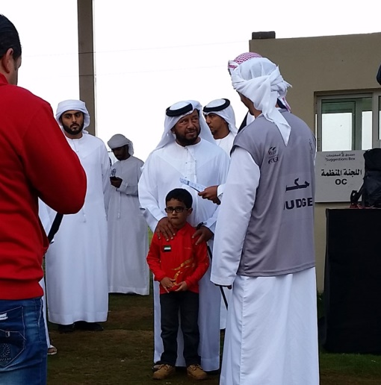
1- HH Sh Sultan bin Zayed Al Nahyan at the entrance of the inspection area during one of his many visits. (photo F. Kerboul)
We must remind the reader that in the early season, an educational set of new rules (called the "Bou Thib Protocol" by the FEI) was created to break the cycle of speed races transposed to endurance which led to the excesses we know about. These excesses had brought the FEI to suspend the National Federation of the UAE in order to regain control. The UAE alone were accumulating the majority of fatal accidents in endurance with only 2% of the CEIs organized worldwide.

A structured whole
Early in the season new rules based on 4 principles were set up.
- To reduce speed by strongly tightening the FEI conventional parameters so that it is, for example, simply impossible to gallop 40 km at 40 km/h while forgetting everything else.
- To establish a joint system taking into account the welfare of the horse in competition by setting up a system of points grading the rider's ability to manage his horse safely (Best Riding Challenge).
- To reward the joint system much better than the traditional classification to make it a more "attractive" component in order to redirect people's attitudes with the help of financial gain.
- To include controlling rules accompanying the determination to return to a healthy sport and supporting the general education purpose.
All this has contributed not only to reduce speed and its bad consequences on the track, but also to change the behavior of the competitors not only vis-à-vis their horses, but also with regard to the way in which they participate and manage their rides.

Convincing results
This resulted in a general improvement of the situation in Bouthieb. Some previously unthinkable scenes were more and more common.
- For example now horses trot on the course instead of galloping continuously (the former had eventually disappeared to exist only for the inspection trottings!).
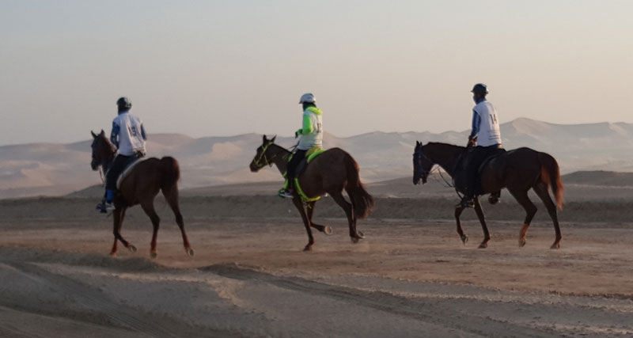
2- Horses trotting on the track. (photo N. Bunyamin)
- We now see horses stopping on the track and quietly drinking at water points, something that had also completely disappeared.
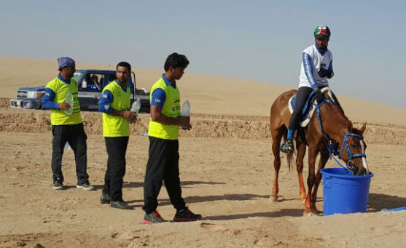
3- A horse drinking on the track with grooms waiting before acting. (photo N. Bunyamin)
- We see no more 4wd races accompanying the horses on the track, their number and route being now strictly controlled.
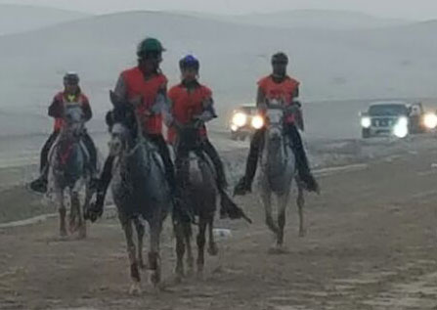
4- End of the 4wd gymkhana. (photo N. Bunyamin)
- We do not see any more agitated crowds surrounding the rider after the crossing of the finish line, dispossessing the Ground Jury of control while allowing, for example, cheating on the weight by means of this "organized confusion".
- Etc.
The last loop of the last day of competition was done on natural terrain, a first test of what will be implemented the next season to make the tracks more technical and thus more challenging.
We saw one of the most famous horse trainers withdraw his horse at the end of the 2nd phase of the CEN Ladies because it had a recovery time of about 3 minutes, while it is usually below one minute. He was proud to communicate this to everyone. Would he have done so last year with a horse placed second when there was only one more phase to go? Would he not have been ashamed to stop at the risk of pushing his horse too far to win at all costs? This action was setting an example and he was totally aware of it.
We saw trainers, spreading the result sheets amid the cups of tea and discussing passionately the strategy to win ... and taking pleasure in it because it is a new and subtle game that does not lack interest.
Many are also those who now feel less under the pressure - sometimes insane - coming from the owners, the trainers and the local environment for whom the only aim is "to win, win, win" and so go as fast as possible (even with this crazy idea of "world speed record" which is totally contrary to the spirit of endurance), thus making endurance a race against time to the exclusion of all other concerns.
The Ground Jury was carefully selected– with some unfortunate exceptions - so that its members were competent, organized, strong and effective. In Bouthieb we no longer saw crowd movements overwhelming the jury during arrivals. Multiple grooms "encouraging" horses with their empty bottles on the track were no longer seen, etc. It proves that the international regulations can be implemented with Ground Jurys composed of a majority of competent members and that it is possible to apply and enforce them everywhere if we really want to.
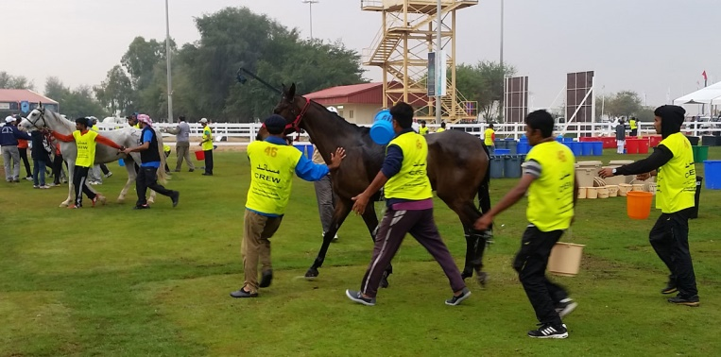
5- Identified grooms with the number of the horse they are in charge of, in a number duly controlled by the Ground Jury. (photo F. Kerboul)
The Veterinary Commissions were also more respectful of equity and horses' welfare than in previous years. The trottings were all recorded with a double aim, namely on the one hand to feed a database for training and on the other being deterrent for those tempted to put the social status of riders before the welfare of the horses as one can sometimes sadly notice.
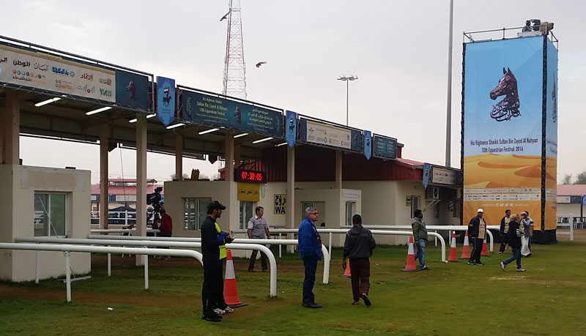
6- Judges and stewards ready to handle the flow of competitors to come (photo F. Kerboul)

A new endurance seminar
Sh Sultan was keen on completing these measures of protection and education with the creation of an endurance seminar. The first edition was held from 04 to 13 March and allowed everyone to listen ten speakers having authority in various fields related to endurance.
Thus Ali Tweissi, the current head of the veterinary department of the National Federation, reported on the positive results obtained in Bouthieb and expressed his satisfaction and that of the department he heads.
Thus we could see Emmett Ross (well-known trainer in the Middle East, organizer of the past WEG in Lexington (USA), and Bromont Montreal (CAN) next to come, etc.) open up new ways and make a general account of the impressions gathered from many of his old fellow trainers.
Thus Dr Sue Stover from the Veterinary Department of the University of California (USA) presented her fascinating research on the ability of bone to adapt to training efforts and the origin of stress fractures due to too fast and intensive training predisposing to complete ruptures as we unfortunately observe many examples in the UAE.
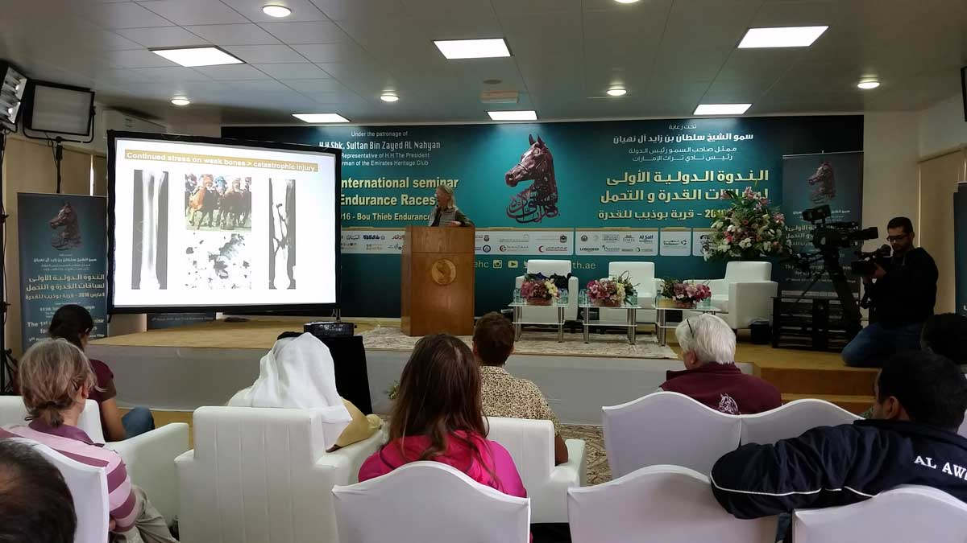
7- Intervention of Dr Sue Stover during the seminar. (photo F. Kerboul).
This seminar was the climax of the season providing an essential complement to the information - training complex implemented in Bouthieb.
We saw two members of the FEI endurance commission (including its president, Brian Sheahan) paying a great deal of attention, because if they knew that something was going on in Bouthieb, they had a rather vague and general idea about it. Brian said that he was very interested and impressed when seeing it all up close.

Grey areas
But if there are many reasons to rejoice in front of the task accomplished this season, long and patient work remains indeed. We do not change, habits in the blink of an eye.
Cheating, which had become a favorite tool of those who aim at victory, has not disappeared, although efforts have been made throughout the season to limit its extent. We know that it is so rooted in the habits that it is not in one season that it will come to an end.
Among the innovative measures implemented during this latest edition of the season, the Organizing Committee had acquired machines to test the hypo sensitivity of horses' legs by point pressure. Due to delivery issues only two machines out of the 10 ordered were implemented in the clinic (and not on the inspection area for regulatory reasons, as the rules have to be updated about this). Only "eliminated" horses underwent the test. It was possible to detect two horses unduly "treated". The consequences for the trainers, perpetrators of this fraud, are not yet known. But the use of these machines was a real shock, for the practice of hypo sensitization (provisional or definitive) is apparently widespread and in fact ignored and unpunished. This test should halt this evil practice inBouthieb.
We unfortunately had to deplore one euthanasia during a qualifier 80 km during the last session (mandatory speed between 12 and 16 km/h). A horse, whose condition was poor, suffered a serious ligament tear. Veterinarians could heal it temporarily and let him go home for further treatment, but the conditions were such that, caring for the horse, they decided otherwise. After analysis, it is clear that the fatal result is not due to the ride itself but to misbehaving during the training and a general poor conditon. This raises once again the question of overtraining (well highlighted by Dr. Sue Stover) as well as the nature of the initial inspection (which had perhaps not been sufficiently cautious, although the number of discarded horses during the initial inspection was much higher this season than in the previous years in Bouthieb).
Some trainers hostile to the new measures expressed their view at the end of the seminar, some giving assessments different from the ones they give in private. They might have been acting this way by submission to others' opinion unless they were still simply struggling to position themselves.
One has probably not sufficiently communicated and explained the articulation of the new rules and they are still esoteric for many people. Certainly they may appear complicated at first, although they are not really, and this is not favorable to popular understanding. But for now, the problem is not to attract crowds of spectators, but to put in the minds of the local participants basic concepts such as respect for the horses in all its aspects and a return to a healthy sport in general. It affects both the knowledge about the horse and its training as well as the instruction of the riders with the prevention of cheating, including doping which is its chemical form.
The measures were intended to extinguish the fire, but they go well beyond this immediate goal. If we are not mistaken, the site of Bouthieb (UAE) is the only place in the world where, instead of talking and meeting endlessly as it has been done here and there in recent years, there has been a concrete implementation of something new and deliberate, going obviously in the right direction and this is worth more than many words. We have been able to measure the positive effects, but also to analyze the deficiencies, and this is a giant step taken in a country severely affected by many unacceptable abuses.
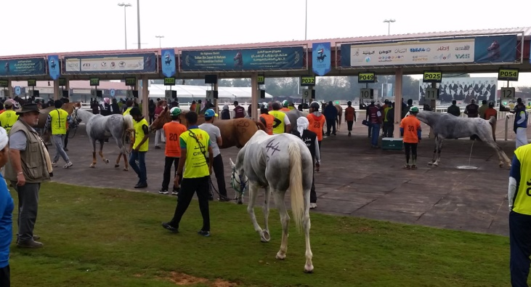
8- An inspection area controlled even during dense moments. One rider and one groom per horse, all of them being clearly identified with the number of the horse they accompany, waiting for their turn automatically displayed on the line screens. (photo F. Kerboul)
"We have yet to see horses kill themselves voluntarily on the track." This sentence heard in response to some statements made at the seminar where some argued that fatalities are an inevitable side effect of high performance sport goes well with one of the first objectives aimed at this year. It appears, on this occasion, that we do not all have the same concept of what is called top sport endurance, which once more asks the fundamental question of progression and instruction, of horses as well as of men, in the current qualification system. It also poses a problem concerning the internal vision of the UAE between the 3 organizing sites and it seems in this end of season that a deep schism is to be expected. It is hoped that it will find a positive way out for horses and sport.
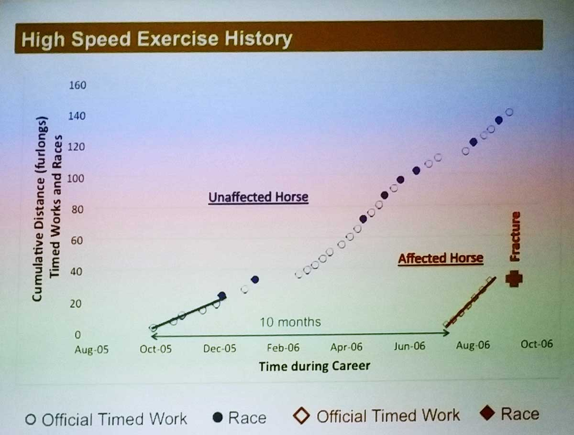
9- Comparison between a correctly trained horse and another one overtrained ending with fracture and euthanasia. (diapositive de Dr Sue Stover)

More "building" work in the near future
Just as too intense and rapid training of the horse leads to its more or less programmed death, rapid qualification "without education" is certainly one of the problems of the discipline and yet its extremely rapid growth and popularity also comes from its opening and we should not break this by setting up a rigid set of rules exclusively in favor of an "elite".
Bouthieb, today, is a place of experiments and it would be foolish to ignore or circumvent it. It has the strength of propositions, demonstration and experimentation of quality with a strong political will without which nothing lasting is possible. We are thinking of fields such as the establishment of prestigious international circuits, the improvement of the qualification process with the creation of a real instruction for riders and horses without killing the current dynamic, a new selection of judges taking - more than today -into account their real capacity to act and make decisions on the ground, a revision of the rules to include geographical diversity which we will have to take into account one day somehow or other , the overhaul of the entire doping control by seriously posing the question of its actual scientific validity and its independence from lobbyists, the promoting of TV and internet domain communication in general, the modes of financing of the rides and the autonomy of organizers face to donors, sponsors and patrons, etc.).
The promoters of the changes in Bouthieb and Sh Sultan at their head, are in no shortage of ideas for the future and, whatever happens, they will go on. it will be done alone or together, but it will not end there.
In short, these days are exciting and it is more than ever time to move.
François Kerboul
FEI 4*
27-03-2016

