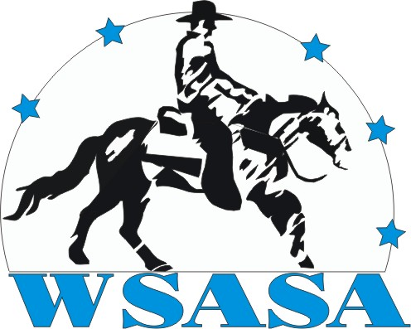
The Western Showing Association of South Africa
P.O. Box 1111, Walkerville, Gauteng, SOUTH AFRICA, 1876. Tel: + 27 78 202 3486. Fax: +27 086 653 6989

The Western Showing Association of South Africa (WSASA) wishes to invite you and your family to a regular fun, day to be held on the 1st Sunday of every month at the Waterpan Stables (see map below).

Each fun day will consist of WSASA games and when suitable will be preceded by an occasional saturday of training showing classes.

Any tack is acceptable (however each funday will have a prize for the best dressed “western rider”) and HARDHATS are HIGHLY recommended for ALL riders.

Game Rules:(the full WSASA rules are available from the society)

- If entries permit classes will be split into the following catagories: lead rein, child, junior and adult.
- Contestants are allowed a running start, and sufficient space will be left before the start line for such to be performed.
- Enough space will be left after the finish line to enable horses to stop easily and without undue trauma to the mouth.
- The judge at his discretion, may diqualify a contestant for excessive use of whip/crop/spur etc.
- Lead rein and child riders may walk and jog only. Juniors and adults may use any gait they find most conveinient.
If entries permit walk/trot junior and adult classes will be offered for novice riders.
- In the case of a tie, the course will be run again.

BARREL RACE.
- Riders shall ride the course as indicated, any deviation from the course will result in penalisation.
- Knocking over a barrel/s will result in a 5 second penalty.

FLAG RACE.
- Riders will cross the start, race to the top barrel, pick up a flag placed in the top barrel, race back to the first barrel and drop the flag in the barrel.
- A rider dropping the flag may dismount, pick up the flag, remount, and drop the flag in the barrel.
- Riders shall ride the course as indicated, any deviation from the course will result in penalisation.
- Knocking over a barrel/s will result in a 5 second penalty.

BENDING RACE.
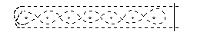
- Riders may start on either side of the first bending pole.
- Riders will cross the start, race to the top bending pole, weave down through the bending poles, weave up through the bending poles and race for home.
- Riders shall ride the course as indicated, any deviation from the course will result in penalisation.
- Knocking over a bending pole/s will result in a 5 second penalty.

PICK-UP RACE.
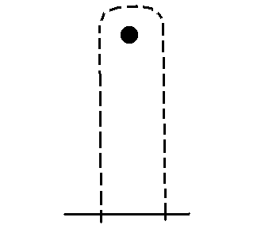
- The passenger shall stand by the top barrel, the passenger must be no more than 5 meters from the barrel at any time.
- Riders will cross the start, race to the top barrel, pick up the passenger (behind the rider) and race for home.
- Both rider and passenger must cross the finish line mounted.
- If a rider losses a passenger , the rider may re-circle the barrel and pick up the passenger again where the passenger dropped of.
- Riders shall ride the course as indicated, any deviation from the course (not picking up the passenger) will result in penalisation.
- Knocking over a barrel will result in a 5 second penalty.

FIGURE EIGHT STAKES RACE.

- Riders will cross the start, race around the top of the righthand barrel, cross back over the start/finish line, race around the bottom of the lefthand barrel and for home.
- Riders shall ride the course as indicated, any deviation from the course will result in penalisation.
- Knocking over a barrel will result in a 5 second penalty.

KEYHOLE RACE.
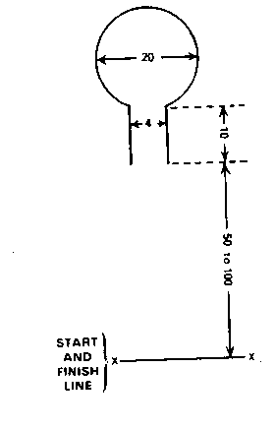
- Riders will cross the start, race into the neck of the keyhole, do a 180 degree turn and race out of the keyhole for home.
- Riders shall ride the course as indicated, any deviation from the course will result in penalisation.
- Horses stepping on or out of the keyhole will incur a 5 second penalty.

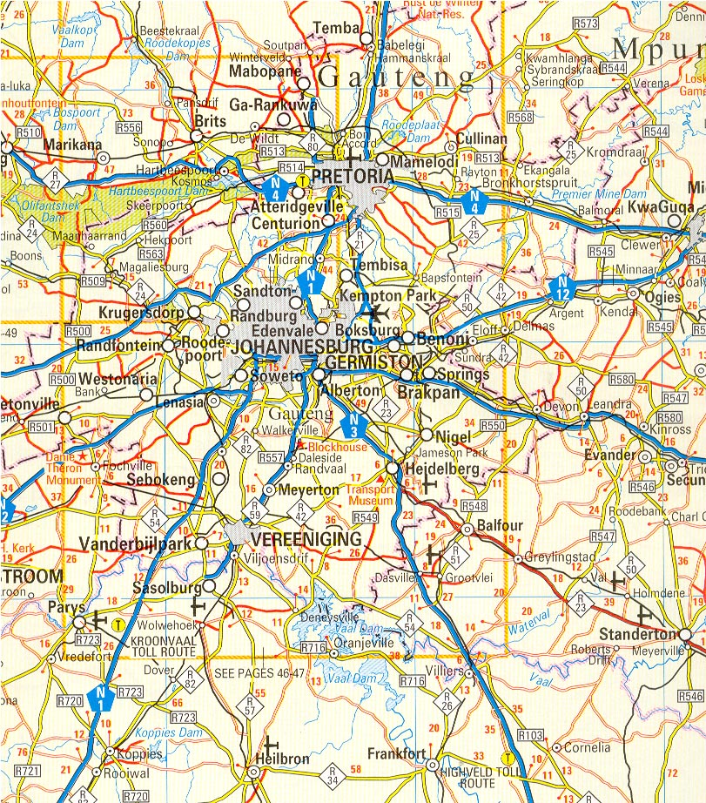
To Johannesburg
R28/N14 To Randfontein
N12
To Potchefstroom
R28/N14 To Vereeniging
Roadhouse and Garage
Waterpan Stables
4 Way Stop
1st Road left after turn at 4-way stop

